**1. Obtain the elements of the union between two character vectors.**

**vec1 = c(rownames(mtcars[1:15,]))**

**vec2 = c(rownames(mtcars[10:32,]))**

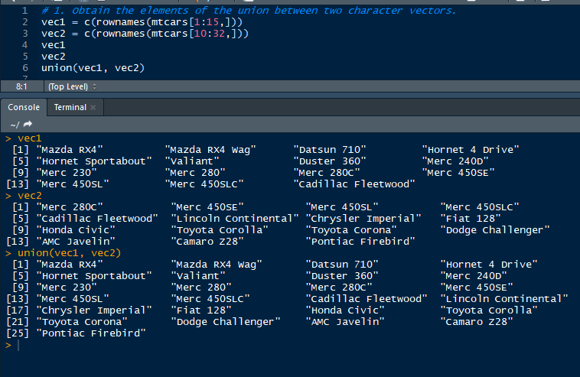

**2. Get those elements that are common to both vectors.**

**vec1 = c(rownames(mtcars[1:15,]))**

**vec2 = c(rownames(mtcars[10:32,]))**

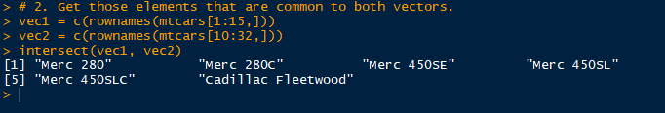

**3. Get the difference of the elements between two character vectors.**

**vec1 = c(rownames(mtcars[1:15,]))**

**vec2 = c(rownames(mtcars[10:32,]))**

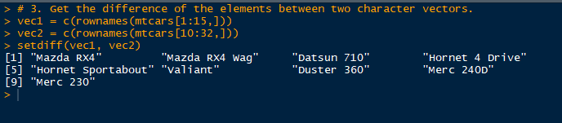

**4. Test the quality of two character vectors.**

**vec1 = c(rownames(mtcars[1:15,]))**

**vec2 = c(rownames(mtcars[11:25,]))**

